Climate Change and Skagit Land Trust’s Conservation Strategy

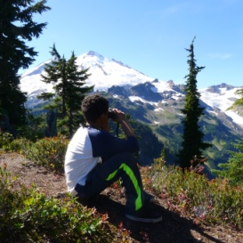

Natural landscapes play an important role in our climate and in climate adaptation. **The EPA estimates that U.S. lands, public and private, together provide nearly 900 million metric tons of annual carbon dioxide removal from the atmosphere.** This represents 15% of total U.S. carbon dioxide emissions. **But there is strong evidence that this sink is being diminished, particularly through loss of forests and grasslands.** Additionally global warming may literally change the face of our conserved lands with rising sea levels and a wide array of unpredictable stresses on plants, fish and wildlife as well as human populations.

Skagit Land Trust’s work is guided by its Conservation Strategy. The strategy identifies conservation targets and uses the best available scientific data and analyses and geographic information system (GIS) mapping tools together with extensive local knowledge and plans to prioritize lands for conservation. Over the years, the Trust has adjusted its criteria and location of priorities to incorporate population growth, evolving science and the effects of climate changes. Our current Strategy is the only compilation of data that is in a useable scale and context to enable community-based, voluntary, local conservation in the Skagit.

Skagit Land Trust's Conservation Strategy addresses climate change by prioritizing land conservation for large blocks of low elevation forests as well as coastal wetlands and wildlife habitat linkages. The Strategy also prioritizes protecting lands that will help build ecosystem resiliency, and will provide the best opportunities for habitat and species adaptation in the face of changing conditions. These concepts are embedded in the Strategy's Guiding Principles, which call out many concepts of landscape ecology and planning for biodiversity, including:

**1. Protect core areas as refugia for species to repopulate surrounding areas,**

**2. Preserve landscape connectivity to allow for species migration and adaptation,**

**3. Protect ecosystem processes that sustain, build and form native habitats.**

For more information, visit www.skagitlandtrust.org or call 360.428.7878

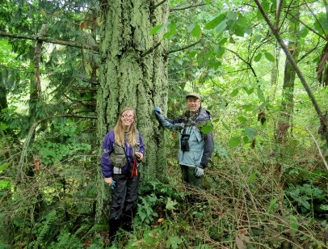

sapsucker.tif